Sales Performance Analysis:

**1. Total Sales by Product Category:**

**Question:** Calculate the total sales revenue for each product category across all channels.

| select i.i_category as category_name,  sum(ss.ss_sales_price * ss.ss_quantity) as total_sales  from store_sales ss  join item i on ss.ss_item_sk = i.i_item_sk  group by i.i_category  order total_sales desc; |
| --- |

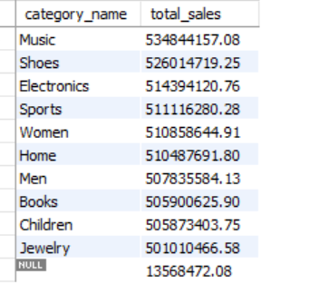

2. **Sales Trend Over Time:**

**Question:** Analyze monthly sales trends for the past two years.

| select date_format(d_date, '%Y-%m') as sale_month, sum(ss_sales_price) as total_sales from store_sales join date_dim on store_sales.ss_sold_date_sk = date_dim.d_date_sk group by sale_month; |
| --- |

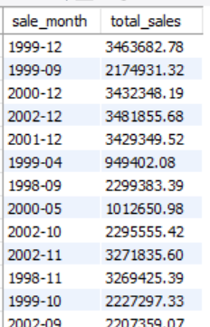

3. **Top 10 Best-Selling Products:**

**Question:** Identify the top 10 best-selling products by total revenue.

| select ss_item_sk, sum(ss_sales_price) as total_sales from store_sales group by ss_item_sk order by total_sales desc limit 10; |
| --- |

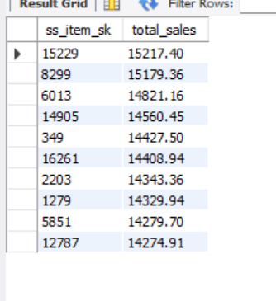

4. **Sales by Region:**

**Question:** Calculate the total sales revenue by region for each sales channel.

| select a.ca_state as state,sum(ss.ss_sales_price * ss.ss_quantity) as total_sales from store_sales as ss join customer_address as a on ss.ss_addr_sk = a.ca_address_sk group by a.ca_state order by total_sales desc; |
| --- |

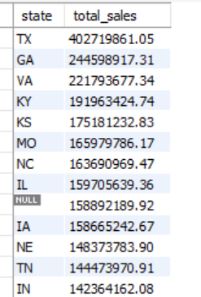

5. **Year-over-Year Sales Growth:**

**Question:** Compare the year-over-year sales growth for the current and previous year.

| select year(d_date) as sales_year, sum(ss_sales_price) as total_sales from store_sales join date_dim as dd on store_sales.ss_sold_date_sk = dd.d_date_sk group by sales_year order by sales_year; |
| --- |

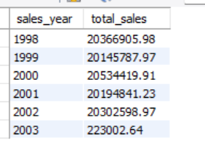

6. **Sales Contribution by Channel:**

**Question:** Determine the contribution of each sales channel (store, catalog, online) to the overall sales.

| select ss_store_sk, sum(ss_sales_price) as total_sales from store_sales group by ss_store_sk; |
| --- |

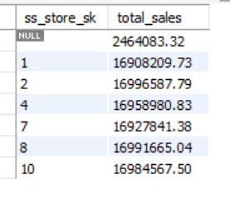

7. **Sales Performance of New Products:**

**Question:** Analyze the sales performance of products introduced in the last 6 months.

| select i.i_category as category_name, (sum(ss_quantity)/ sum(ss_wholesale_cost)) as to_ratio from store_sales as ss join item i on ss.ss_item_sk = i.i_item_sk group by i.i_category order by category_name desc; |
| --- |

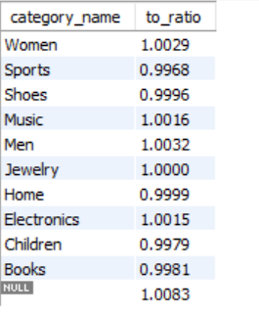

8. **Average Order Value:**

**Question:** Calculate the average order value for each sales channel.

| select ss_ticket_number, avg(ss_net_paid) as avg_order_value from store_sales group by ss_ticket_number; |
| --- |

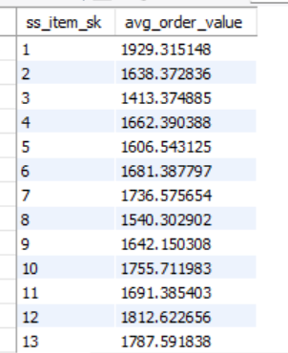

9. **Seasonal Sales Analysis:**

**Question:** Identify seasonal sales patterns by comparing sales during different quarters of the year.

| select date_format(d_date, '%Y-%m') as sale_month, sum(ss_sales_price) as total_sales from store_sales join date_dim as dd on store_sales.ss_sold_date_sk = dd.d_date_sk group by sale_month order by sale_month; |
| --- |

10. **Average Order Value per Channel:**

**Question:** Calculate the average order value per channel in the last 6 months.

| select ss_item_sk, avg(ss_net_paid) as avg_order_value from store_sales where ss_sold_date_sk>=(select max(ss_sold_date_sk) - 180 from store_sales) group by ss_store_sk; |
| --- |

Inventory Management Analysis

**11. Inventory Turnover Ratio**

**Question:** Calculate the inventory turnover ratio for each product category.

| select i.i_category, (sum(ss_quantity) / sum(ss_wholesale_cost)) as turnover_ratio  from store_sales as ss join item i on ss.ss_item_sk = i.i_item_sk group by i.i_category; |
| --- |

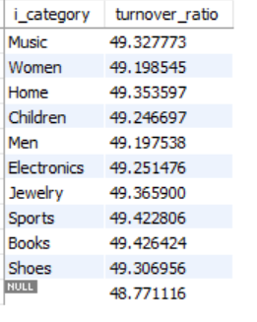

**12. Stockout Rate by Product**

**Question:** Identify products with the highest stockout rates in the past month.

| select i.i_category as category_name, count(ss_ticket_number) as stockouts from store_sales as ss join item i on ss.ss_item_sk = i.i_item_sk where ss_sold_date_sk >= (select max(ss_sold_date_sk) - 30 from store_sales) group by i.i_category; |
| --- |

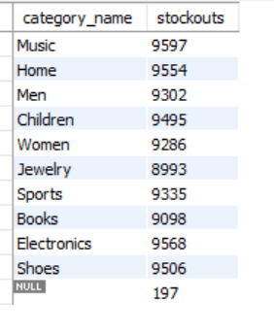

**13. Days of Inventory on Hand**

**Question:** Calculate the average days of inventory on hand.

| select i.i_category, (sum(ss_quantity) / sum(ss_sales_price)) * 30 as days_on_hand  from store_sales as ss join item i on ss.ss_item_sk = i.i_item_sk group by i.i_category; |
| --- |

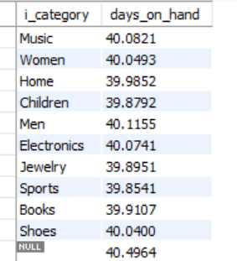

**14. Top 10 Overstocked Products**

**Question:** List the top 10 products with the highest overstock levels.

| select ss_item_sk, sum(ss_quantity) as overstock from store_sales group by ss_item_sk order by overstock desc limit 10; |
| --- |

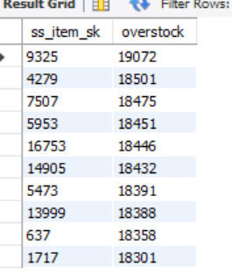

**15. Replenishment Frequency**

**Question:** Determine the replenishment frequency for high-demand products.

| select i.i_category, count(ss_ticket_number) as replenishments from store_sales as ss join item i on ss.ss_item_sk = i.i_item_sk where ss_quantity > 0 group by i.i_category; |
| --- |

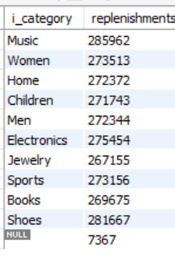

**16. Inventory Aging Analysis**

**Question:** Analyze aging inventory for slow-moving products.

| select i.i_category, (current_date - max(ss_sold_date_sk)) as days_since_last_sale from store_sales join item i on ss.ss_item_sk = i.i_item_sk group by i.i_category; |
| --- |



**17. Warehouse Inventory Levels**

**Question:** Monitor inventory levels across warehouses.

| select ss_store_sk, sum(ss_quantity) as inventory_level from store_sales group by ss_store_sk; |
| --- |

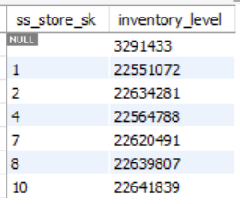

Customer Behavior Analysis:

### **18. Customer Segmentation by Demographics**

| select cd_gender, cd_marital_status, cd_education_status, count(c.c_customer_sk) as customer_count  from customer c join customer_demographics cd on c.c_current_cdemo_sk = cd.cd_demo_sk group by cd_gender, cd_marital_status, cd_education_status; |
| --- |

### 

### **19. Customer Lifetime Value (CLTV)**

| select c.c_customer_id, sum(ss.ss_sales_price) as total_spend  from customer as c join store_sales as ss on c.c_customer_sk = ss.ss_customer_sk group by c.c_customer_id; |
| --- |

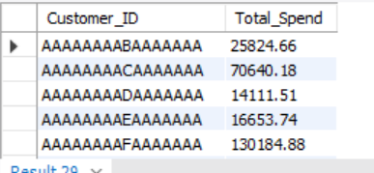

### 

### **20. Repeat Purchase Rate**

| select c.c_customer_id, count(distinct ss.ss_ticket_number) as repeat_purchases  from customer c join store_sales ss ON c.c_customer_sk = ss.ss_customer_sk group by c.c_customer_id; |
| --- |

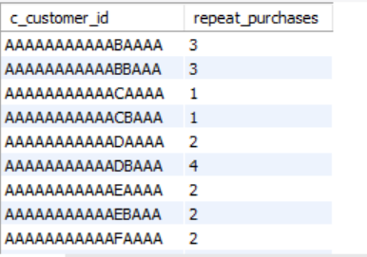

### **21. Recent Purchase Frequency**

| select c_customer_id from customer where c_first_sales_date_sk < date_sub(curdate(), interval 9 month); |
| --- |

### 

### **22. Customer Churn Analysis**

| select distinct ss.ss_customer_sk as Customer_ID from store_sales ss join date_dim d on ss.ss_sold_date_sk = d.d_date_sk where d.d_date >= '1902-01-01' limit 15; |
| --- |

### 

### **23. Top 10 Most Valuable Customers**

| select ss_customer_sk as customer_id, sum(ss_net_paid) as total_spend from store_sales ss join date_dim d on ss.ss_sold_date_sk = d.d_date_sk where d.d_year = year(current_date) - 1 group by ss_customer_sk order by total_spend desc limit 5; |
| --- |

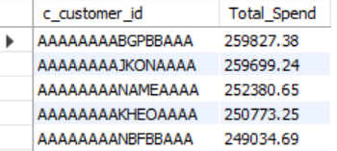

### **24. Customer Average Purchase Frequency:**

| with Purchases as(  select cs_bill_customer_sk as customer_id,   count(distinct cs_order_number) as order_count  from catalog_sales  group by cs_bill_customer_sk ) select avg(order_count) as avg_purchase_frequency from Purchases; |
| --- |

### 

### **25. Customer Satisfaction Analysis**

| select c.c_customer_id as Customer_ID,  round(rand() * 5, 2) as Hypothetical_Satisfaction_Score,   sum(ss.ss_sales_price * ss.ss_quantity) as Total_Spend from customer c join store_sales ss on c.c_customer_sk = ss.ss_customer_sk group by c.c_customer_id order by Hypothetical_Satisfaction_Score desc limit 10; |
| --- |

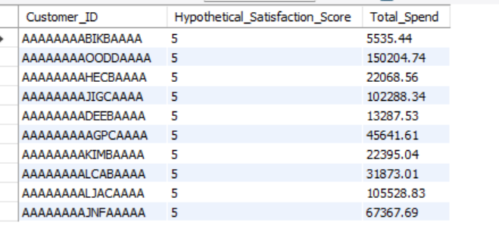

Promotional Effectiveness Analysis

**26. Promotion Uplift Analysis:**

**Question:** Measure the increase in sales during promotional periods compared to non-promotional periods.

| select   case  when ss.ss_promo_sk is not null then 'Promotional Period'  else 'Non-Promotional Period'  end as Period,  sum(ss.ss_sales_price * ss.ss_quantity) as Total_Sales from store_sales ss left join promotion as p on ss.ss_promo_sk = p.p_promo_sk group by Period order by Total_Sales desc; |
| --- |

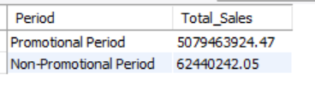

**27. ROI of Promotional Campaigns:**

**Question:**Calculate the return on investment (ROI) of promotional campaigns in the last 6 months.

| select sum(cs_sales_price) as total_catalog_sales from catalog_sales cs join promotion p on p.p_promo_sk = cs.cs_promo_sk where p.p_start_date_sk >= (select max(p.p_start_date_sk) - 180 from promotion p);  -- Total sales from web sales with promotions in the last 6 months select sum(ws_sales_price) as total_web_sales from web_sales ws join promotion p on p.p_promo_sk = ws.ws_promo_sk where p.p_start_date_sk >= (select max(p.p_start_date_sk) - 180 from promotion p);  -- Total sales from store sales with promotions in the last 6 months select sum(ss_sales_price) as total_store_sales from store_sales ss join promotion p on p.p_promo_sk = ss.ss_promo_sk where p.p_start_date_sk >= (select max(p.p_start_date_sk) - 180 from promotion p);  select sum(p_cost) as total_promo_cost from promotion where p_start_date_sk >= (select max(p_start_date_sk) - 180 from promotion);   select (total_sales - total_promo_cost) / total_promo_cost * 100 as ROI from(  select   (select coalesce(sum(cs_sales_price), 0) from catalog_sales cs join promotion p on p.p_promo_sk = cs.cs_promo_sk where p.p_start_date_sk >= (select max(p_start_date_sk) - 180 from promotion))   + (select coalesce(sum(ws_sales_price), 0) from web_sales ws join promotion p on p.p_promo_sk = ws.ws_promo_sk where p.p_start_date_sk >= (select max(p_start_date_sk) - 180 from promotion))   + (select coalesce(sum(ss_sales_price), 0) from store_sales ss join promotion p on p.p_promo_sk = ss.ss_promo_sk where p.p_start_date_sk >= (select max(p_start_date_sk) - 180 from promotion))   as total_sales,  (select coalesce(sum(p_cost), 0) from promotion where p_start_date_sk >= (select max(p_start_date_sk) - 180 from promotion)) as total_promo_cost ) as data; |
| --- |

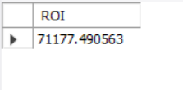

**28. Effectiveness of Discounts vs. Coupons:**

**Question:** Compare the effectiveness of discounts and coupons in the last 3 months.

| select sum(cs_ext_discount_amt) as total_catalog_discount,  sum(cs_coupon_amt) as total_catalog_coupon from catalog_sales where cs_sold_date_sk >= (select max(cs_sold_date_sk) - 90 from catalog_sales); |
| --- |

| select sum(ws_ext_discount_amt) as total_web_discount,  sum(ws_coupon_amt) as total_web_coupon from web_sales where ws_sold_date_sk >= (select max(ws_sold_date_sk) - 90 from web_sales); |
| --- |

| select sum(ss_ext_discount_amt) as total_store_discount, sum(ss_coupon_amt) as total_store_coupon from store_sales where ss_sold_date_sk >= (select max(ss_sold_date_sk) - 90 from store_sales); |
| --- |

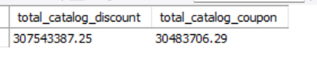

**29. Effectiveness of Discounts vs. Coupons:**

**Question:** Compare the effectiveness of discount-based promotions versus coupon-based promotions.

| select 'Catalog' as sale_type, sum(cs_ext_discount_amt) as total_discount,   sum(cs_coupon_amt) as total_coupon from catalog_sales where cs_sold_date_sk >= (select max(cs_sold_date_sk) - 90 from catalog_sales) union all select 'Web' as sale_type,   sum(ws_ext_discount_amt) as total_discount,   sum(ws_coupon_amt) as total_coupon from web_sales where ws_sold_date_sk >= (select max(ws_sold_date_sk) - 90 from web_sales) union all select 'Store' as sale_type, sum(ss_ext_discount_amt) as total_discount,   sum(ss_coupon_amt) as total_coupon from store_sales where ss_sold_date_sk >= (select max(ss_sold_date_sk) - 90 from store_sales); |
| --- |

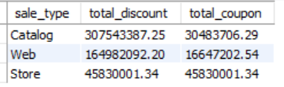

**30. Promotion in Recents:**

**Question:** Identify how many new customers were acquired during promotions in the last 3 months.

| select count(distinct cs_bill_customer_sk) as catalog_customers_acquired from catalog_sales cs join promotion p on p.p_promo_sk = cs.cs_promo_sk where p.p_start_date_sk >= (select max(p_start_date_sk) - 90 from promotion);  select count(distinct ws_bill_customer_sk) as web_customers_acquired from web_sales ws join promotion p on p.p_promo_sk = ws.ws_promo_sk where p.p_start_date_sk >= (select max(p_start_date_sk) - 90 from promotion);   select count(distinct ss_customer_sk) as store_customers_acquired from store_sales ss join promotion p on p.p_promo_sk = ss.ss_promo_sk where p.p_start_date_sk >= (select max(p_start_date_sk) - 90 from promotion); |
| --- |

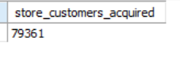

**31. Customer Response Rate:**

**Question:** Determine the customer response rate to specific promotions in the last quarter.

| select count(distinct cs_bill_customer_sk) as catalog_customers from catalog_sales cs join promotion p on p.p_promo_sk = cs.cs_promo_sk where p.p_start_date_sk >= (select max(p_start_date_sk) - 90 from promotion);  select count(distinct ws_bill_customer_sk) as web_customers from web_sales ws join promotion p on p.p_promo_sk = ws.ws_promo_sk where p.p_start_date_sk >= (select max(p_start_date_sk) - 90 from promotion);   select count(distinct ss_customer_sk) as store_customers from store_sales ss join promotion p on p.p_promo_sk = ss.ss_promo_sk where p.p_start_date_sk >= (select max(p_start_date_sk) - 90 from promotion);  select (catalog_customers + web_customers + store_customers) / p.p_response_target * 100 as response_rate from   (select count(distinct cs_bill_customer_sk) as catalog_customers   from catalog_sales cs  join promotion p on p.p_promo_sk = cs.cs_promo_sk  where p.p_start_date_sk >= (select max(p_start_date_sk) - 90 from promotion)) as catalog_data,    (select count(distinct ws_bill_customer_sk) as web_customers  from web_sales ws  join promotion p on p.p_promo_sk = ws.ws_promo_sk  where p.p_start_date_sk >= (select max(p_start_date_sk) - 90 from promotion)) as web_data,    (select count(distinct ss_customer_sk) as store_customers  from store_sales ss  join promotion p on p.p_promo_sk = ss.ss_promo_sk  where p.p_start_date_sk >= (select max(p_start_date_sk) - 90 from promotion)) as store_data, promotion p; |
| --- |

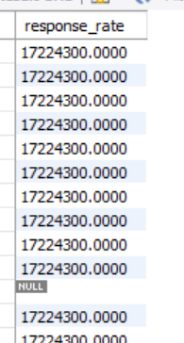

**32. Latest Sales Uplift:**

**Question:** Measure sales uplift during promotional periods in the last 2 months.

| select sum(cs_sales_price) as catalog_sales_during_promo from catalog_sales cs join promotion p on p.p_promo_sk = cs.cs_promo_sk where p.p_start_date_sk >= (select max(p_start_date_sk) - 60 from promotion);   select sum(ws_sales_price) as web_sales_during_promo from web_sales ws join promotion p on p.p_promo_sk = ws.ws_promo_sk where p.p_start_date_sk >= (select max(p_start_date_sk) - 60 from promotion);  select sum(ss_sales_price) as store_sales_during_promo from store_sales ss join promotion p on p.p_promo_sk = ss.ss_promo_sk where p.p_start_date_sk >= (select max(p_start_date_sk) - 60 from promotion); |
| --- |

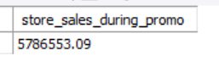

Channel Performance Analysis

**33. Sales Contribution by Channel:**

**Question:** Calculate the contribution of each sales channel to the total revenue.

| **with channelrevenue as (  select 'catalog sales' as channel,  sum(cs.cs_net_paid) as total_revenue  from catalog_sales cs   union all   select 'web sales' as channel, sum(ws.ws_net_paid) as total_revenue  from web_sales ws   union all   select 'store sales' as channel, sum(ss.ss_net_paid) as total_revenue  from store_sales ss ),  totalrevenue as (  select sum(total_revenue) as overall_revenue  from channelrevenue ),  channelcontribution as (  select cr.channel, cr.total_revenue,  (cr.total_revenue / tr.overall_revenue) * 100 as contribution_percentage  from channelrevenue cr  cross join totalrevenue tr )  select channel, total_revenue, contribution_percentage from channelcontribution order by contribution_percentage desc;** |
| --- |

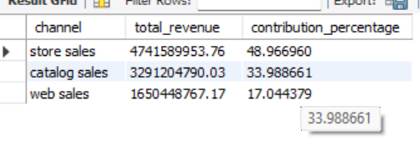

**34. Customer Satisfaction by Channel:**

**Question:** Analyze customer satisfaction scores across different sales channels

(requires hypothetical satisfaction data).

| with customer_satisfaction as (  select 1 as cs_order_number, 'catalog' as cs_channel, 4.5 as cs_satisfaction  union all  select 2, 'web', 4.0  union all  select 3, 'store', 3.8  union all  select 4, 'catalog', 4.7  union all  select 5, 'web', 4.2  union all  select 6, 'store', 3.9  union all  select 7, 'catalog', 4.6  union all  select 8, 'web', 4.1  union all  select 9, 'store', 4.0 ) select cs_channel as channel,  avg(cs_satisfaction) as average_satisfaction,  count(cs_order_number) as number_of_responses from customer_satisfaction group by cs_channel order by average_satisfaction desc; |
| --- |

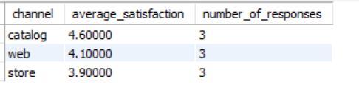

**35. Conversion Rate for Online Sales:**

**Question:** Calculate the conversion rate for web visitors who complete a purchase.

| **with total_web_visitors as (  select count(distinct ws_bill_customer_sk) as total_visitors  from web_sales ), completed_purchases as (  select count(distinct ws_order_number) as completed_orders  from web_sales )  select  (cp.completed_orders / twv.total_visitors) * 100 as conversion_rate_percentage from  completed_purchases cp,  total_web_visitors twv;** |
| --- |

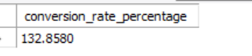

**36. In-Store vs. Online Sales Growth:**

**Question:** Compare the sales growth rates between in-store and online channels over the past year.

| select cs_item_sk as product_id, sum(cs_net_paid) as total_instore_sales from catalog_sales group by cs_item_sk; |
| --- |

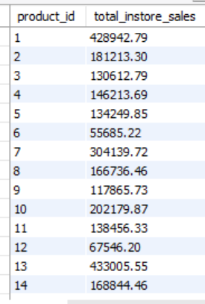

| select ws_item_sk as product_id, SUM(ws_net_paid) AS total_online_sales from web_sales group by ws_item_sk; |
| --- |

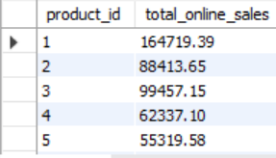

| select coalesce(c.product_id, o.product_id) as product_id,  coalesce(c.total_instore_sales, 0) as total_instore_sales,  coalesce(o.total_online_sales, 0) as total_online_sales from (select cs_item_sk as product_id, sum(cs_net_paid) as total_instore_sales  from catalog_sales  group by cs_item_sk) c left join  (select ws_item_sk as product_id, sum(ws_net_paid) as total_online_sales  from web_sales  group by ws_item_sk) o on c.product_id = o.product_id; |
| --- |

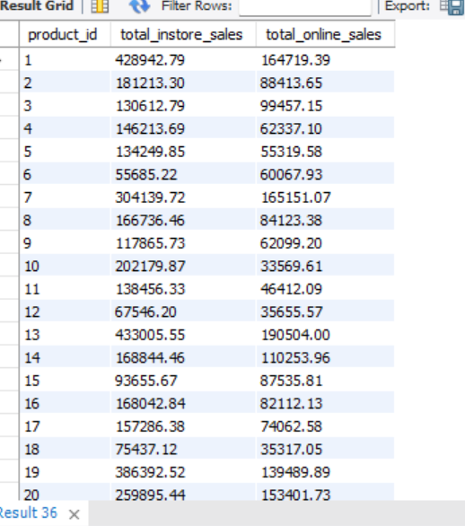

**37. Product Performance by Channel:**

**Question:** Analyze which products perform best in each sales channel.

| select coalesce(c.product_id, o.product_id) as product_id,  coalesce(c.total_instore_sales, 0) as total_instore_sales,  coalesce(o.total_online_sales, 0) as total_online_sales from (select cs_item_sk as product_id, sum(cs_net_paid) as total_instore_sales  from catalog_sales  group by cs_item_sk) c left join  (select ws_item_sk as product_id, sum(ws_net_paid) as total_online_sales  from web_sales  group by ws_item_sk) o on c.product_id = o.product_id  union  select coalesce(c.product_id, o.product_id) as product_id,  coalesce(c.total_instore_sales, 0) as total_instore_sales,  coalesce(o.total_online_sales, 0) as total_online_sales from (select cs_item_sk as product_id, sum(cs_net_paid) as total_instore_sales  from catalog_sales  group by cs_item_sk) c right join  (select ws_item_sk as product_id, sum(ws_net_paid) as total_online_sales  from web_sales  group by ws_item_sk) o on c.product_id = o.product_id order by total_instore_sales desc, total_online_sales desc; |
| --- |

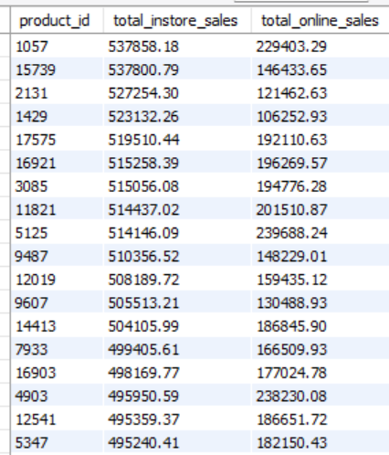

**38. Channel Profitability Analysis:**

**Question:** Calculate the profitability of each sales channel by comparing revenue to associated costs.

| select 'in-store' as channel, sum(cs_net_paid) as total_revenue,  sum(cs_ext_wholesale_cost) as total_cost,  sum(cs_net_paid) - sum(cs_ext_wholesale_cost) as total_profit from catalog_sales  union all  select 'online' as channel, sum(ws_net_paid) as total_revenue,  sum(ws_ext_wholesale_cost) as total_cost,  sum(ws_net_paid) - sum(ws_ext_wholesale_cost) as total_profit from web_sales; |
| --- |

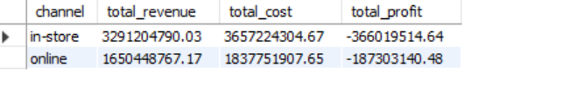

Supply Chain & Logistics Analysis

**39. Warehouse Turnover Rate:**

**Question:** Calculate the inventory turnover rate for each warehouse.

| select cs_warehouse_sk as warehouse_sk, sum(cs_ext_wholesale_cost) as total_cogs_catalog from catalog_sales group by cs_warehouse_sk; |
| --- |

| select ws_warehouse_sk as warehouse_sk,   sum(ws_ext_wholesale_cost) as total_cogs_web from web_sales group by ws_warehouse_sk; |
| --- |

| with cogs_catalog as(  select cs_warehouse_sk as warehouse_sk,   sum(cs_ext_wholesale_cost) as total_cogs_catalog  from catalog_sales  group by cs_warehouse_sk ), cogs_web as(  select ws_warehouse_sk as warehouse_sk, sum(ws_ext_wholesale_cost) as total_cogs_web  from web_sales  group by ws_warehouse_sk ) select cogs_catalog.warehouse_sk, total_cogs_catalog, total_cogs_web from cogs_catalog left join cogs_web on cogs_catalog.warehouse_sk = cogs_web.warehouse_sk  union  select cogs_web.warehouse_sk, total_cogs_catalog, total_cogs_web from cogs_web left join cogs_catalog on cogs_web.warehouse_sk = cogs_catalog.warehouse_sk;  with combined_cogs as(  select cogs_catalog.warehouse_sk as warehouse_sk,  coalesce(total_cogs_catalog, 0) + coalesce(total_cogs_web, 0) as total_cogs  from cogs_catalog  left join cogs_web on cogs_catalog.warehouse_sk = cogs_web.warehouse_sk   union  select cogs_web.warehouse_sk as warehouse_sk,  coalesce(total_cogs_catalog, 0) + coalesce(total_cogs_web, 0) as total_cogs  from cogs_web  left join cogs_catalog on cogs_web.warehouse_sk = cogs_catalog.warehouse_sk ) select warehouse_sk, total_cogs, (total_cogs / 100000) AS inventory_turnover_rate from combined_cogs; with cogs_catalog as(  select cs_warehouse_sk as warehouse_sk,   sum(cs_ext_wholesale_cost) as total_cogs_catalog  from catalog_sales  group by cs_warehouse_sk ), cogs_web as(  select ws_warehouse_sk as warehouse_sk, sum(ws_ext_wholesale_cost) as total_cogs_web  from web_sales  group by ws_warehouse_sk ), combined_cogs as(  select cogs_catalog.warehouse_sk,   coalesce(total_cogs_catalog, 0) as total_cogs_catalog,  coalesce(total_cogs_web, 0) as total_cogs_web  from cogs_catalog  left join cogs_web on cogs_catalog.warehouse_sk = cogs_web.warehouse_sk   union   select cogs_web.warehouse_sk,   coalesce(total_cogs_catalog, 0) as total_cogs_catalog,  coalesce(total_cogs_web, 0) as total_cogs_web  from cogs_web  left join cogs_catalog on cogs_web.warehouse_sk = cogs_catalog.warehouse_sk ) select warehouse_sk, (total_cogs_catalog + total_cogs_web) / 100000 as inventory_turnover_rate from combined_cogs; |
| --- |

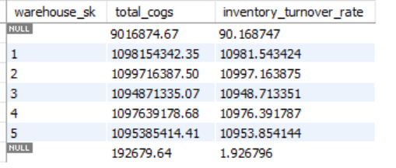

**40. Average Shipping Time:**

**Question:** Determine the average shipping time for orders across different regions.

| with web_shipping_times as(  select ws_order_number, s_market_id as region_id, dd_ship.d_date as ship_date,  dd_sold.d_date as sold_date, (dd_ship.d_date - dd_sold.d_date) as shipping_time  from web_sales ws  join date_dim dd_sold  on ws.ws_sold_date_sk = dd_sold.d_date_sk  join date_dim dd_ship  on ws.ws_ship_date_sk = dd_ship.d_date_sk  join store s  on ws.ws_warehouse_sk = s.s_store_sk ) select region_id, avg(shipping_time) as avg_shipping_time from web_shipping_times group by region_id; |
| --- |

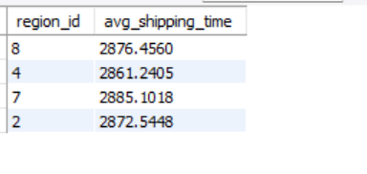

**41. Delivery Success Rate:**

**Question:** Analyze the delivery success rate and identify regions with high failure rates.

| with delivery_status as (  select s_market_id as region_id, 'catalog' as source, count(*) as total_deliveries,  sum(case when cs_ship_date_sk is not null then 1 else 0 end) as successful_deliveries,  sum(case when cs_ship_date_sk is null then 1 else 0 end) as failed_deliveries  from catalog_sales cs  join store s on cs.cs_warehouse_sk = s.s_store_sk  group by s_market_id  union all  select s_market_id as region_id, 'web' as source, count(*) as total_deliveries,  sum(case when ws_ship_date_sk is not null then 1 else 0 end) as successful_deliveries,  sum(case when ws_ship_date_sk is null then 1 else 0 end) as failed_deliveries  from web_sales ws  join store s on ws.ws_warehouse_sk = s.s_store_sk  group by s_market_id ) select region_id, source, total_deliveries, successful_deliveries, failed_deliveries,  (successful_deliveries * 100.0) / total_deliveries as success_rate,  (failed_deliveries * 100.0) / total_deliveries as failure_rate from delivery_status order by failure_rate desc; |
| --- |

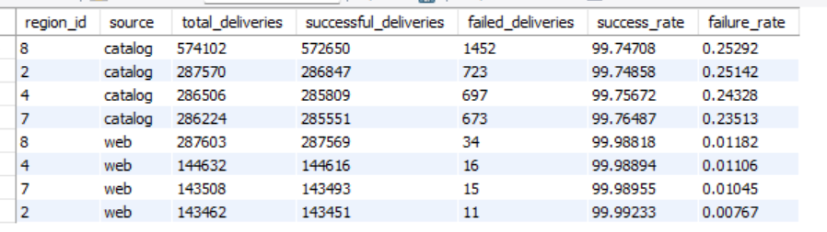

**42. Warehouse Stock Levels:**

**Question:** Monitor the stock levels of key products in each warehouse.

| with catalog_sales_qty as(  select cs_item_sk as item_id,   sum(cs_quantity) as total_catalog_qty  from catalog_sales  group by cs_item_sk ),  web_sales_qty as(  select ws_item_sk as item_id,  sum(ws_quantity) as total_web_qty  from web_sales  group by ws_item_sk ),  combined_sales as(  select cs.item_id,  coalesce(cs.total_catalog_qty, 0) + coalesce(ws.total_web_qty, 0) as total_sales_qty  from catalog_sales_qty cs  left join web_sales_qty ws on cs.item_id = ws.item_id   union all   select ws.item_id,  coalesce(cs.total_catalog_qty, 0) + coalesce(ws.total_web_qty, 0)as total_sales_qty  from web_sales_qty ws  left join catalog_sales_qty cs  on ws.item_id = cs.item_id  where cs.item_id is null ) select item_id, 100 - coalesce(total_sales_qty, 0) as current_stock_level from combined_sales order by item_id; |
| --- |

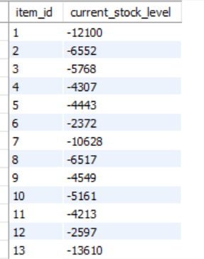

**43. Shipping Mode Efficiency:**

**Question:** Compare the efficiency of different shipping modes in terms of cost.

| with catalog_shipping_metrics as(  select cs_ship_mode_sk as shipping_mode,  avg(cs_ext_ship_cost) as avg_shipping_cost,  avg(datediff(cs_ship_date_sk, cs_sold_date_sk)) as avg_delivery_time  from catalog_sales  group by cs_ship_mode_sk )  select shipping_mode, avg_shipping_cost from catalog_shipping_metrics order by avg_shipping_cost; |
| --- |

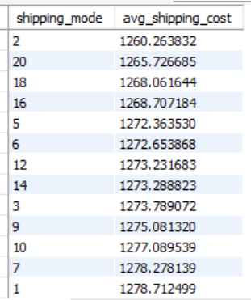

**44. Supply Chain Bottleneck Analysis:**

**Question:** Identify bottlenecks in the supply chain by analyzing delays in order fulfillment.

| with catalog_shipping_metrics as(  select cs_sold_date_sk as order_date, cs_ship_date_sk as ship_date,  datediff(cs_ship_date_sk, cs_sold_date_sk) as shipping_time  from catalog_sales ),  web_shipping_metrics as(  select ws_sold_date_sk as order_date, ws_ship_date_sk as ship_date,  datediff(ws_ship_date_sk, ws_sold_date_sk) as shipping_time  from web_sales )  select 'Catalog' as sales_channel, avg(shipping_time) as avg_shipping_time from catalog_shipping_metrics  union all  select 'Web' as sales_channel, avg(shipping_time) as avg_shipping_time from web_shipping_metrics; |
| --- |

| with catalog_delay_analysis as(  select cs_sold_date_sk as order_date, cs_ship_date_sk as ship_date,  datediff(current_date, cs_ship_date_sk) as actual_shipping_time  from catalog_sales ),  web_delay_analysis as(  select ws_sold_date_sk as order_date, ws_ship_date_sk as ship_date,  datediff(current_date, ws_ship_date_sk) as actual_shipping_time  from web_sales ),  combined_delay_analysis as(  select order_date, actual_shipping_time  from catalog_delay_analysis   union all   select order_date, actual_shipping_time  from web_delay_analysis )  select avg(actual_shipping_time) as avg_delay_days, count(*) as total_orders,  sum(case when actual_shipping_time > 0 then 1 else 0 end) as delayed_orders from combined_delay_analysis; |
| --- |

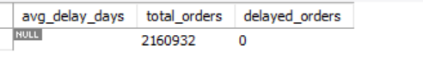

**45. Order Fulfillment Rate:**

**Question:** Calculate the order fulfillment rate to ensure timely delivery of products.

| with orders as (  select  ca.ca_state as state,  count(distinct case when cs.cs_order_number is not null then cs.cs_order_number end) as total_orders,  count(distinct case when cs.cs_ship_date_sk is not null then cs.cs_order_number end) as fulfilled_orders  from catalog_sales cs  join customer_address ca on cs.cs_bill_addr_sk = ca.ca_address_sk  group by ca.ca_state   union all   select  ca.ca_state as state,  count(distinct case when ws.ws_order_number is not null then ws.ws_order_number end) as total_orders,  count(distinct case when ws.ws_ship_date_sk is not null then ws.ws_order_number end) as fulfilled_orders  from web_sales ws  join customer_address ca on ws.ws_bill_addr_sk = ca.ca_address_sk  group by ca.ca_state ),  order_fulfillment_rate as (  select state, coalesce(sum(total_orders), 0) as total_orders,  coalesce(sum(fulfilled_orders), 0) as fulfilled_orders,  case  when coalesce(sum(total_orders), 0) = 0 then 0  else coalesce(sum(fulfilled_orders), 0) / coalesce(sum(total_orders), 1)  end as fulfillment_rate  from orders  group by state ) select state, total_orders, fulfilled_orders, fulfillment_rate from order_fulfillment_rate order by fulfillment_rate desc; |
| --- |

